PMI Sydney Chapter Volunteers Profiles
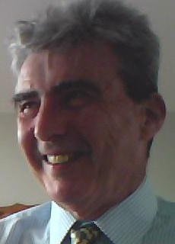
Peter O’Driscoll
Peter has been a Sydney Chapter volunteer for almost 10 years. He has served on the Board for 7 of these as Treasurer, Professional Development Director and Vice-President.
In addition to volunteering as a Certification Preparation presenter, he is a volunteer with the Community Coaching program, and also undertakes periodic assignments on behalf of the Board. Peter is a long time member of Toastmasters International and recently helped to establish the Sydney Chapter Toastmasters Club.
Peter sees the benefits of volunteering to include being able to contribute to the advancement of the profession, the sense of achievement from initiating and being involved in the delivery of member services, making a contribution to the wider community, and building strong relationships with fellow Board members, Chapter members and the broader PMI community.
Peter is a PMP and PMI-ACP qualified project, program and change manager. In prior years he has practiced as a consultant, and a financial controller, supported by appropriate qualifications. Peter intends to move into project management coaching and training and is currently studying for the Certificate IV Training and Assessment training qualification.

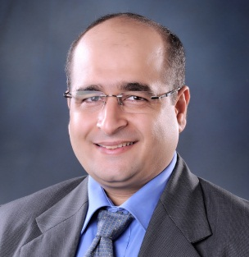
Mansoor Mohammed
Mansoor is a Senior Program/Project Management professional, Leadership Mentor, Trainer and Consultant with a mission to help program/project managers transform themselves into leadership roles and deliver better projects/programs.
Mansoor has been practicing and mentoring program/project management for various industries by practicing and involving training on project management concepts, PMI certification, setting up program infrastructure, program/project management office and governance structure.
As a passionate trainer & mentor Mansoor would like to extend and share the knowledge acquired through experience & current PMI methodologies by joining the PMI Sydney Training Team. He sees several benefits in volunteering such as being able to contribute to the advancement of the program/project management profession and mentor aspiring professionals.
Mansoor is the 19th Program Management Professional - PgMP credential holder in Australia and among very few with 4 PMI accreditations (PgMP, PMP, RMP, SP), he is currently working towards achieving the latest PMI Credentials Portfolio Management Professional PfMP.
Good things happen when you get involved with PMI Sydney!

